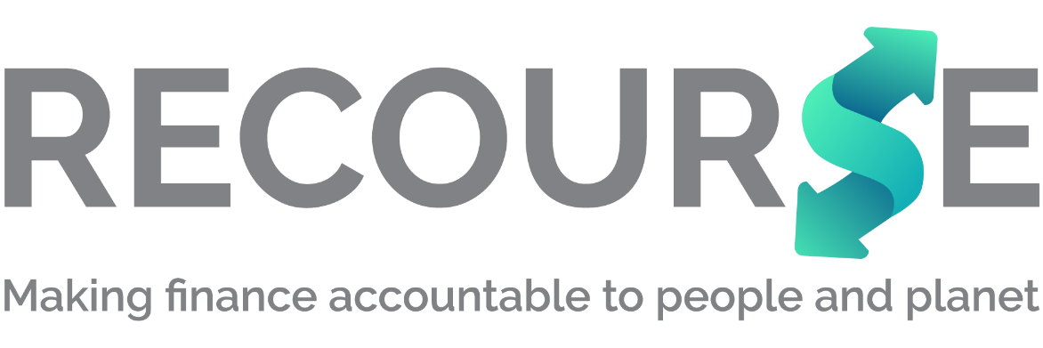

Submission to EBRD consultation on its Paris alignment methodology for indirect finance
February 2022

Overall comments
The European Bank for Reconstruction and Development (EBRD) is the first multilateral development bank (MDB) to move to propose a Paris alignment methodology for indirect finance. The EBRD is to be commended for tackling this difficult issue. At the same time, this makes it all the more important to get this right as it is the first and so will set the precedent for other development banks. Therefore, the methodology must be ambitious and set a high bar to prompt a race to the top in addressing the role of public finance in tackling the climate crisis.

It is welcome that the EBRD will review the methodology every year. This will be an opportunity to fine tune the methodology and ensure it responds to the latest demands and increases ambition. It is vital that such reviews are based on outcomes: where the money invested by EBRD through financial intermediary clients has ended up and what its climate impact has been. We also encourage EBRD to ensure such reviews be open to public consultation and input, to allow scrutiny and ensure EBRD is accountable to its commitments.

Urgency and ambition
Though there are some promising proposals in the methodology, overall, Recourse finds the proposed methodology lacks ambition and urgency. We are running out of time to prevent runaway climate change and cannot wait for the pace of gradual change proposed in this methodology. Public finance has a unique role to play in ensuring the shift from dirty, fossil-based investments to a green and sustainable future. The EBRD’s 8 billion euro financial intermediary (FI) portfolio should be a catalyst for this shift.

Transparency
The methodology fails to set out how transparency will be assured around FI investments and why it is needed. It is widely acknowledged (see Publish What You Fund’s latest research on DFI FI transparency) that transparency is a significant problem in FI investing. Too often there is little to no information about where money ends up. This increases the risk that FI investments may ultimately finance fossil fuels, as Recourse research on the International Finance Corporation (IFC) Recourse research has shown. Enhanced transparency can shine a light on such risks and thus reduce them, ensuring the EBRD is accountable to its commitments. It is welcome that EBRD discloses all of its high risk, Category A, sub-investments via FIs, but this does not go far enough. As research has consistently shown, projects or FIs themselves may be miscategorised at a lower risk level (for example, Category B) than is warranted by the project’s impacts. For example, the IFC categorised its FI client Hana Bank Indonesia as FI2 – or medium risk – though the bank went on to fund two massive new coal plants in Indonesia in 2020.

To set a clear requirement for other MDBs, as well as for the EBRD, it is vital that the methodology state up front that transparency is central to any methodology addressing Paris alignment (the goal to stay below 1.5 degrees Celsius of warming). It should state that medium and high-risk sub-projects financed through FIs will be disclosed publicly – at least the name, sector and location. Without this, civil society will not be able to track whether EBRD is living up to its Paris alignment commitment.

Second, this methodology will only apply to new FI clients. This means that EBRD’s existing 8 billion euro FI portfolio will not be Paris aligned. This is not good enough and the methodology must set out how EBRD will apply this to its existing FI clients.

Third, Pillar 2 is the one that will truly show whether sub projects financed via FIs are Paris aligned. And yet Pillar 2 will only apply to some debt clients. It must apply across all debt and equity clients, to ensure all EBRD-financed subprojects are Paris aligned.

Fourth EBRD Paris alignment definition allows for mid and downstream oil and gas – but public finance should not be used to subsidise oil and gas. Public money should fund the transition to sustainable, renewable energy. Note that 51% of your shareholders have signed up at COP26 to commitment to ‘’end new direct public support for the international unabated fossil fuel energy sector by the end of 2022’’ so are already leading the way on this transition.

Specific comments on the methodology
  - It is welcome that the methodology mentions keeping global warming below the 2 degrees limit and the 1.5 degrees goal, but it should place more emphasis on the need to stay below 1.5 degrees, including targets and timelines to achieve this.

  - EBRD committed to align all investments by end of 2022 (earlier than other MDBs eg IFC and the Asian Infrastructure Investment Bank) which is welcome. But it is clear after reading the document, that this is not the case. EBRD will instead be applying a methodology that will gradually help clients become more Paris aligned (eg by 2027). But in no way can this be described as all EBRD investments being Paris aligned.

1.7 It is good that EBRD will review its Paris alignment methodology annually, to reflect lessons learned and other initiatives including by other MDBs. (See comment above.)

1.10 EBRD recognises that it can have a catalytic effect through its FI lending – with its impact on FIs wider than just its own investments: “by capitalising on its interactions with PFIs to promote their Paris alignment, the EBRD can impact financial flows that are many times larger than its own lending volumes.” This increases the responsibility of the EBRD to ensure it is doing all it can to support the alignment of FI clients and their investments.

1.12 EBRD will help its FI clients to transition, through the development of “institutional transition plans”. “These plans will, among other things, set a route for the transformation of their lending portfolios, establish underlying business practices to deliver on their ambitions and work towards public disclosure.” As mentioned above, without sufficient public disclosure, there will be no accountability for whether Paris alignment is a reality or not. But the draft does not address disclosure in a clear and defined way – this is a missed opportunity. (See comments on transparency above.)

1.13 The methodology will be implemented from Jan 2023 and will only apply to new investments, This means that the rest of the FI portfolio – which totals billions of euros - will not be aligned. It is clear that the EBRD will NOT align all its investments by end 2022. The EBRD states that 80% of its existing FI clients will get repeat business with EBRD and when new investments occur, the Paris alignment methodology will be applied. This is not sufficient. The EBRD must set out a strategy to address its existing FI portfolio as soon as possible. For example, the IFC has set out its Greening Equity Approach which applies to existing equity clients.

1.15: Accountability: “[the methodology’s] application is independently verified by the Bank’s “second line of defence” under the purview of the Chief Risk Officer.” It is vital that the methodology be subject to open and transparent evaluation, not solely in-house, to ensure it is delivering with the ambition and urgency required.

1.18: The EBRD will apply a Paris alignment filter to some debt investments (pillar two). For equity and general purpose liquidity (ie those investments which expose the EBRD to the FI’s entire portfolio) “pillars 3 and 4 will be prioritised and form the basis of alignment determination.” Pillar 2 should also apply to equity clients and to general purpose debt clients – to ensure all EBRD FI sub projects align with the Paris Agreement. There is no reason why equity investments – where the EBRD actually takes a share in an FI client – should be exempted from the requirements of Pillar 2.

This exemption undermines the whole principle of green equity – using the leverage equity investments give to have influence over the entire portfolio. The EBRD could use a similar approach to IFC’s coal exclusion in equity investments, using EBRD’s much stronger fossil fuel exclusion language.

1.19 “where sub-transaction alignment is less clear or not possible, the focus on institutional transformation will be introduced immediately.” What does less clear or not possible mean? Does this excuse EBRD-backed sub projects from being Paris aligned? This is a get-out clause, which threatens to undermine the EBRD’s pledge to be Paris aligned and should be removed.

1.20 Although the methodology will be launched in 2023, it appears that alignment through pillars three and four won’t happen until 2027. The EBRD should set a much clearer and more ambitious timeline.

1.22 The Paris alignment plan (pillar four) will be different for each FI, not standard – to account for differences in regulations, climate practices etc. This could lead to there being loopholes which FI clients can exploit. It is imperative that the EBRD set out clear baseline requirements that apply to all FI clients. The methodology must also clearly state what penalties it will apply in cases where FIs do not meet its requirements for Paris alignment.

2.9 Pillar 3 evaluates the FI’s climate action against “leading market and regulatory practice”. This is the wrong metric and will not ensure the urgent action required to avert runaway climate change. The EBRD must ensure FIs’ climate action is measured against what averting the climate crisis requires.

2.11 The pillar 1 commitment “it is a commitment, in the context of the EBRD methodological application, to move towards business practices that are consistent with the goals of the Paris Agreement and to work with the EBRD, partner MDBs, a development institution or an impact investor to implement that commitment.” This fundamental commitment should be much clearer and timebound, giving targets and dates.

2.14: Fossil fuel exclusions will apply to all FI transactions:
“All EBRD intermediated financing, regardless of financial instrument, is subject to relevant Bank policies on fossil-fuel exclusion. The EBRD will not knowingly finance, directly or indirectly through financial intermediaries, projects where EBRD proceeds are used for activities relating to thermal coal mining, coal-fired electricity generation or upstream oil and gas.”
This is welcome, but as many have pointed out, an exclusion for upstream oil and gas alone is not sufficient. The EBRD must exclude all fossil fuels and the infrastructure that supports them, in common with the European Investment Bank.

2.15 Paris alignment will be defined by the EBRD’s methodology for direct finance: “sub-transactions permitted under policy statements between the EBRD and its PFIs would typically be determined Paris aligned under the EBRD’s Paris alignment methodology for directly financed investments.” Since the methodology for direct finance alignment allows for mid and downstream oil and gas, this commitment is not sufficient. The EBRD should ensure its methodologies for both direct and indirect finance are explicit in ruling out all fossil fuels support.

Numbers used here refer to the EBRD paragraphs

